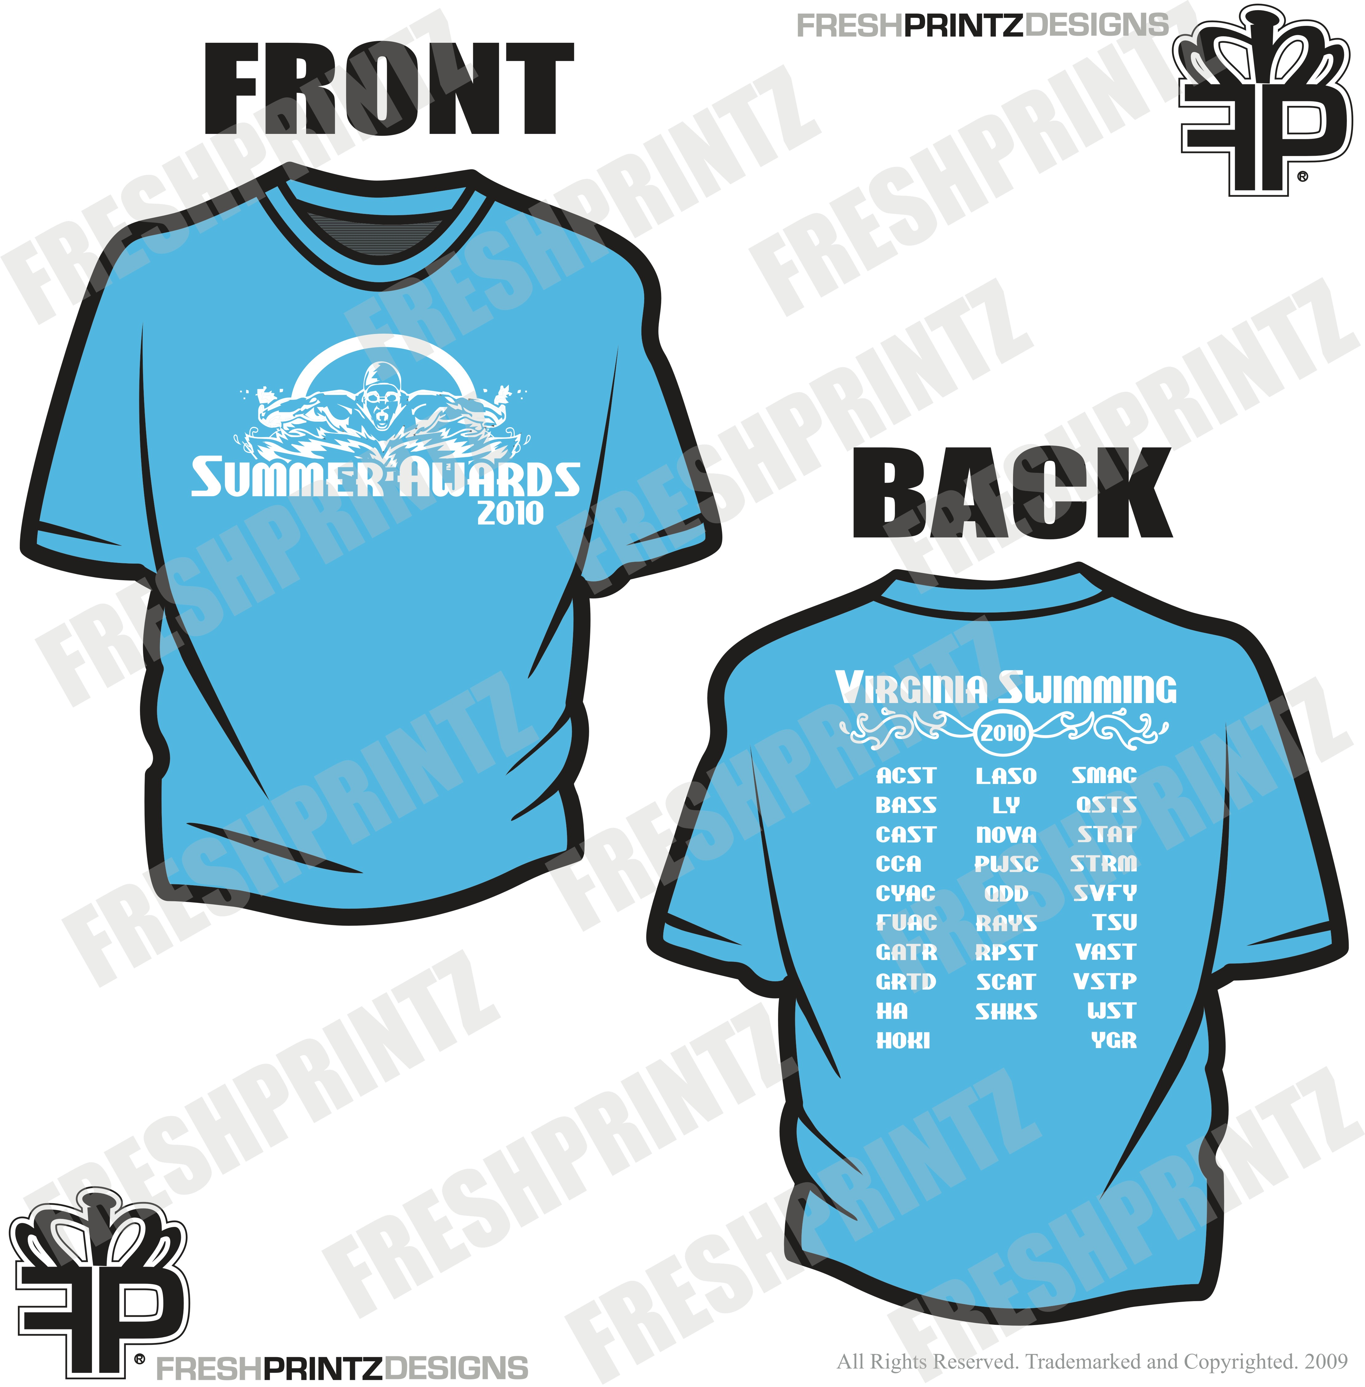
Summer Awards Hosted by RAYS
Pre-meet Apparel Orders are due on
Friday, July 2, 2010

Apparel available: Canary blue short sleeved T-shirts, tank tops and
mesh shorts in youth and adults sizes. If purchased at the meet, the
cost will be $3 more per item. There will also be other meet apparel available at the meet.

Name: ______________ Team: ____

E-mail: ______________ Phone: ____

Address: _________________________

City/ State/Zip: ________

Pre-orders can be picked up in concessions during regular hours.

Item | Size | Quantity | Price | Total for line
Adult Canary Blue Short Sleeve T-shirt w/ meet logo silk-screened | S M L XL |  | $12
Adult Canary Blue Tank Top w/ meet logo silk-screened | S M L XL |  | $14
Adult Canary Blue nylon mesh shorts w/ meet logo silk-screened | S M L XL |  | $18
Youth Canary Blue Short Sleeve T-shirt w/ meet logo silk-screened | S(6-8) M(10-12) L(14-16) |  | $12
Youth Canary Blue Tank Top w/ meet logo silk-screened | S(6-8) M(10-12) L(14-16) |  | $14
Youth Canary Blue nylon mesh shorts w/ meet logo silk-screened | S(6-8) M(10-12) L(14-16) |  | $18
Total for order |  |  |  | $
Make checks payable to RAYS.
Mail order form and payment to: Bob Herlinger
10609 King Eider Ct.
Spotsylvania, VA 22553

