Virginia Swimming
proudly presents
Eric Shanteau
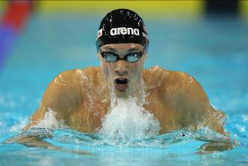
2008 Olympian, 2012 Olympic Gold Medalist,
American & World Record Holder, and Cancer Survivor

This 4 hour clinic includes a motivational talk,
stroke clinic, and in-water demonstration.

Participants must be 8 & older and registered with Virginia Swimming.
Goodie bag and drinks will be provided.

When: Saturday, September 29, 2012
Time: 10:00 AM – 2:00 PM, check–in 9:30 AM
Where: Collegiate School Aquatics Center
5050 Ridgedale Parkway, Richmond, VA
Cost: $25

Please complete the registration form below and mail it with your check for $25 made payable to Virginia Swimming to:
Virginia Swimming Inc.
PO Box 1059
Appomattox, VA 24522

Space is limited to the first 120 swimmers!

Shanteau Swim Clinic

Name____________________________Phone #___________

Address___________________________________________

Age________ VSI Team_______ Email__________________

Questions call 434-352-5451 or email: businessoffice@virginiaswimming.org

