Virginia Swimming
proudly presents
David Walters
2008 Olympian, 3 time World Champion, American Record Holder,
former Virginia Swimmer

This 4 hour clinic includes a motivational talk,
stroke clinic, and in-water demonstration.

Participants must be 8 & older and registered with Virginia Swimming.
Goodie bag and drinks will be provided.

When: Saturday, October 1, 2011
Time: 10:00 AM – 2:00 PM, check–in 9:30 AM
Where: Brock Recreation Center
Randolph Macon College
400 N. Center Street, Ashland, VA
Cost: $25

Please complete the registration form below and mail it with your check for $25 made payable to Virginia Swimming to:
Virginia Swimming Inc.
PO Box 1059
Appomattox, VA 24522

Space is limited to the first 120 swimmers!

Walters Swim Clinic

Name____________________________Phone #___________

Address___________________________________________

Age________ VSI Team_______ Email__________________

Questions call 434-352-5451 or email: businessoffice@virginiaswimming.org
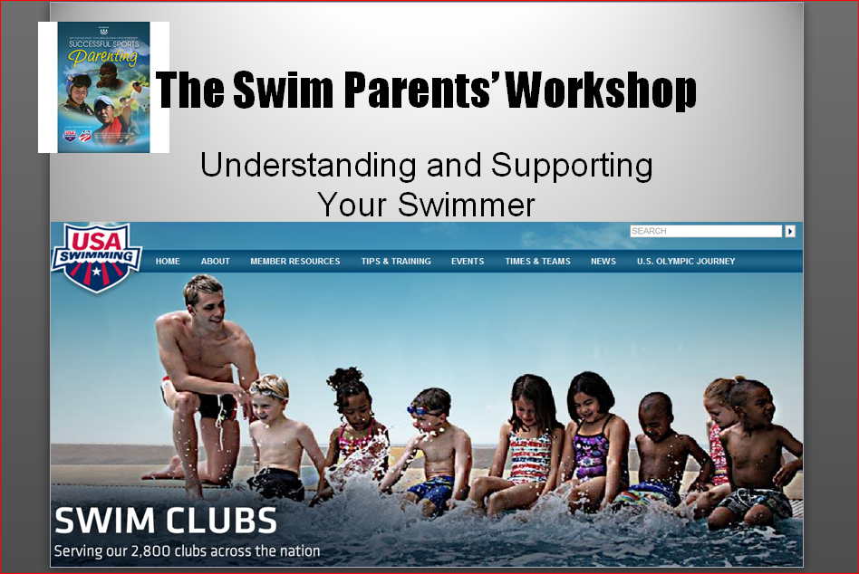

Parent Workshop

While your swimmer is participating in the Athlete Clinic you can participate in a workshop led by Peter Clark, our very own Eastern Zone Sports Consultant. With his 35 years of coaching experience at the age group, YMCA, high school, and college levels, he has a wealth of information to share. Peter plans to discuss everything a parent needs to know about the growing athlete swimmer from growth and development to nutrition and how swimmers mature in the sport.

Directions to Brock Recreation Center:

From I-95, take Exit 92B to Ashland (Route 54). Go through three stop lights and turn right onto North Center Street, approx. 1.5 miles (will be just before the railroad tracks). The Recreation Center will be on the right less than .5 miles from the intersection. Parking will be at the Business Office which is almost directly across the street and on the opposite side of the railroad tracks. To get there, go past the Recreation Center and make a u turn to cross the tracks. Parking will be behind the Business Office.

